INTERDIGITATED ELECTRODES IN MICROFLUIDICS

Erin Ingram & Omar Mahmood

**Concept of Operations**

Concept of Operations

for

Interdigitated Electrodes in Microfluidics

Team #78, Erin Ingram and Omar Mahmood

Approved by:

_____________________________

Erin Ingram Date

_____________________________

Prof. Kalafatis Date

_____________________________

T/A Date

**Change Record**

| **Rev.** | **Date** | **Originator** | **Approvals** | **Description** |
| --- | --- | --- | --- | --- |
| **1** | 9/14/2022 | [Erin Ingram, Omar Mahmood] |  | Draft Release |
| **2** | 10/1/2022 | [Erin Ingram, Omar Mahmood] |  | Grammatical and formatting fixes |
| **3** | 12/4/2022 | [Erin Ingram, Omar Mahmood] |  | Final Report |

**Table of Contents**

**Table of Contents III**

**List of Tables IV**

**No table of figures entries found. IV**

**List of Figures V**

1. Size-based droplet filtration using microfluidic channel with IDE array **V**

**1.** **Executive Summary** 6

**2.** **Introduction** 7

2.1. Background 7

2.2. Overview 7

2.3. Referenced Documents and Standards 8

**3.** **Operating Concept** 10

3.1. Scope 10

3.2. Operational Description and Constraints 10

3.3. System Description 11

3.4. Modes of Operations 11

3.5. Users 11

3.6. Support 11

**4.** **Scenario(s)** 12

4.1. Cell Biology 12

4.2. Drug Screening 12

4.3. Nucleic Acid Analysis applications 12

**5.** **Analysis** 13

5.1. Summary of Proposed Improvements 13

5.2. Disadvantages and Limitations 13

5.3. Alternatives 13

5.4. Impact 13

**List of Tables**

No table of figures entries found.

**List of Figures**

1. Size-based droplet filtration using microfluidic channel with IDE array 8

# 

# 1. Executive Summary

Droplet microfluidics deals with the manipulation of discrete volumes of fluid as small as several microliters through small microchannel devices and it has shown promise in many different biological and chemical applications, including cell biology, drug screening, and nucleic acid analysis applications. However, regardless of the generation structures, the viscoelasticity led to the problem of formation of satellite droplets during generation. These are undesired since they can negatively affect the precise manipulation of desired droplets. In addition, these droplets in biological applications are seen in the cross contamination between fluids during downstream processing. To address these issues, a new method and system must be proposed to alleviate the problem by addressing the issue of satellite droplet generation. Size-based filtration uses electric forces and spatial channels to help direct specific sized droplets to certain outlets to be processed and analyzed. The size-based filtration method can be further enhanced using interdigitated electrode (IDE) arrays. IDE arrays can more finely tune and control electric fields which allows the method to be more sensitive when attempting to spatially filter droplets by DEP force. As a relatively novel solution, the IDE bandpass filtration method has potential to usher in a breakthrough in the quality control of satellite droplet formation.

# Introduction

## 2.1. Background

Droplet microfluidics deals with the manipulation of discrete volumes of fluid as small as several ul through small microchannel devices and it has shown promise in many different biological and chemical applications, including cell biology, drug screening, and nucleic acid analysis applications (5). Among varieties of different droplet manipulation methods, the droplet generation is the first and most significant step. Two mechanisms are generally used to create the droplets (1) T-junction structure, where immiscible fluids (for example, water-in-oil) are mixed from two channels into a third containing the droplets.  (2) flow-focusing structure where one fluid is introduced from two separate directions with a different fluid from another outlet to form the droplet. Encapsulation of viscoelastic fluids for droplet generation is common in applications like food engineering, cell lysis and droplet PCR. However, regardless of the generation structures, the viscoelasticity led to the problem of formation of satellite droplets during generation. These are undesired since they can negatively affect the precise manipulation of desired droplets. In addition, these droplets in biological applications are seen in the cross-contamination between fluids during downstream processing. Such an example is in the case of library generation for bacterial and viral experiments where satellite droplets can merge with desired droplets containing sensitive organic compounds where mixing is not tolerated. The result is a set of false-positive or false-negative results which might require retesting and can be expensive as well as time consuming.

## 2.2. Overview

To address these issues, a new method and system must be proposed to alleviate the problem by addressing the issue of satellite droplet generation. There are two possible solutions: torsional fracture to minimize the satellite droplet formation and size-based filtration of satellite droplets. Torsional fracture works on the principle of rotating the liquid bridge which induces shear and stress on the thinning neck. As the ends of the liquid spread, the neck begins to pinch off without the formation of a satellite droplet. Size-based filtration uses electric forces and spatial channels to help direct specific sized droplets to certain outlets to be processed and analyzed. The size-based filtration method can be further enhanced using interdigitated electrode (IDE) arrays (1). IDE arrays can more finely tune and control electric fields which allows the method to be more sensitive when attempting to spatially filter droplets by DEP force. As a relatively novel solution, the IDE bandpass filtration method has potential to usher in a breakthrough in the quality control of satellite droplet formation.

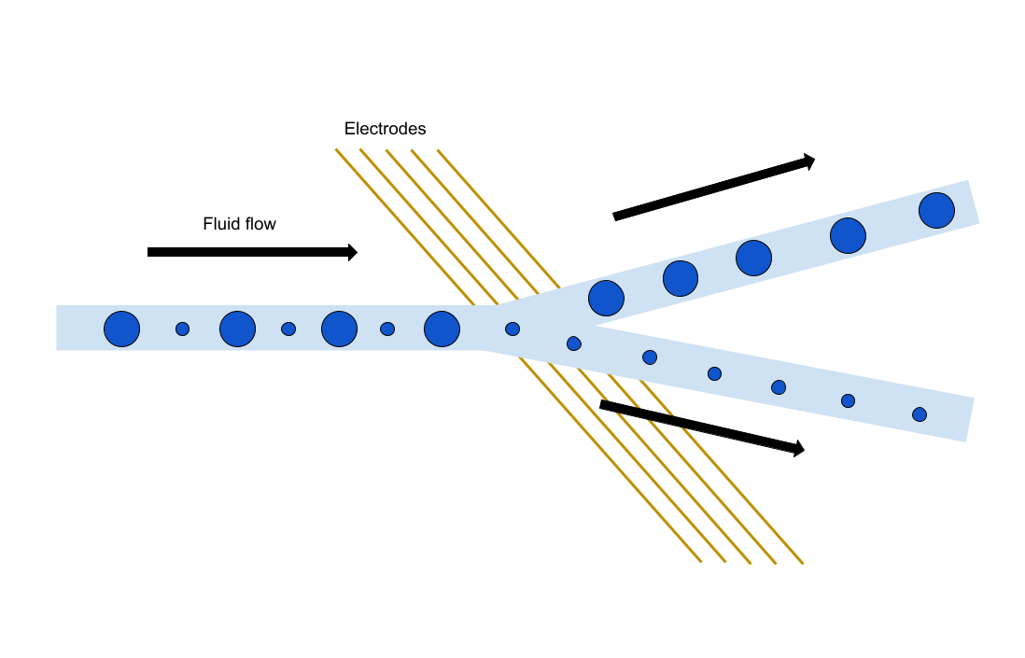

*Figure 1.* Size-based droplet filtration using microfluidic channel with IDE array

## 

## 2.3. Referenced Documents and Standards

[1] Zhang, Han & Huang, Can & Li, Yuwen & Gupte, Rohit & Samuel, Ryan & Dai, Jing & Guzman, Adrian & Sabnis, Rushant & Figueiredo, Paul & Han, Arum. (2022). FIDELITY: A quality control system for droplet microfluidics. Science Advances. 10.1126/sciadv.abc9108.

[2] Li M, van Zee M, Goda K, Di Carlo D. Size-based sorting of hydrogel droplets using inertial microfluidics. Lab on a Chip. 2018 Aug;18(17):2575-2582. DOI: 10.1039/c8lc00568k. PMID: 30046787.

[3] Chan, S. T., van Berlo, F. P., Faizi, H. A., Matsumoto, A., Haward, S. J., Anderson, P. D., & Shen, A. Q. (2021). Torsional fracture of viscoelastic liquid bridges. Proceedings of the National Academy of Sciences, 118(24), e2104790118.

[4] S.Y. Teh, R. Lin, L.H. Hung, A. Lee. Droplet microfluidics. (2007). DOI: 10.1039/b715524g

[5] T. Kaminski, O. Scheler, P. Garstecki. Droplet microfluidics for microbiology: techniques, applications and challenges. (2016). DOI: 10.1039/c6lc00367b

[6] Carrier, O., Dervin, E., Funfschilling, D. et al. Formation of satellite droplets in flow-focusing junctions: volume and neck rupture. Microsyst Technol 21, 499–507 (2015). https://doi.org/10.1007/s00542-013-1905-x

[7] Zhang, Han & Guzman, Adrian & Wippold, Jose & Li, Yuwen & Dai, Jing & Huang, Can & Han, Arum. (2020). An Ultra High-Efficiency Droplet Microfluidics Platform Using Automatically Synchronized Droplet Pairing and Merging. Lab on a Chip. 10.1039/D0LC00757A.

[8] Kim, HS, Hsu, S-C, Han, S-I, et al. High-throughput droplet microfluidics screening platform for selecting fast-growing and high lipid-producing microalgae from a mutant library. Plant Direct. 2017; 00: 1– 13. https://doi.org/10.1002/pld3.11

# Operating Concept

## 3.1. Scope

The two students will individually create two different microfluidics channel designs. We will each start by fabricating our own channels and testing from satellite droplet formation to form a control group. Next we will individually apply different sized based filtrations, IDE arrays, and test for satellite droplet formation, and compare to the control group. Fabrication will include the use of the Cleanroom in the AggieFab facility for methodologies such as photolithography, softlithography, metal deposition, wet etching, dry etching, and device integration.

## 3.2. Operational Description and Constraints

The system will be designed as a sort of multi-stage filtration system on the micro level. The desired fluid will enter the system through a channel as droplets. These droplets will be in different sizes. The droplets will then enter the first IDE, which will have a width of between 6 - 10 microns. The field being produced from the IDE will separate the droplets into two different channels, one channel being the one that can pass through the IDE and one that cannot. The droplets that fail to pass through the IDE will be considered waste, while the droplets that do pass will go on to the second IDE. This IDE will have a width of between 10 -15 microns, and will be used to separate the remaining droplets. The droplets that are able to pass through the field of this IDE will be the final droplets and will be considered usable, while the droplets that cannot pass will be considered waste. At the end of this filtration system, the output is a droplet of the correct size and no lagging droplet that comes with it. This will prevent contamination, false readings and unwanted reactions that would have been caused by the satellite droplets. The constraints for this system are as follows:

Fixed width of the IDE. As of now, the IDE will have a fixed width of X microns and will not be adjustable by the user in the experiment.

The field that will be produced by the IDE will not be adjustable during the experiment.

## 3.3. System Description

The first subsystem will be a high pass filter. An IDE of a width of between 6 -10 microns will be fabricated. This IDE will then connect to a battery, which will produce a field to separate the droplets based on size. If a droplet is large enough to pass through the IDE, it will be sent on a path to the second IDE, whereas if it is not large enough, it will be sent to another path and will be considered waste. This system, when completed should have a near 100% accuracy rate of filtering out droplets based on size greater than 6-10 microns.

The second subsystem would be a band pass filter IDE and carry off from the first stage IDE. The droplets remaining would theoretically be of a larger size and would not be categorized as satellite droplets. However, there would still be some remaining droplets that do not fit the size and/or volume requirements. This second IDE subsystem would be able to filter out these undesired droplets. The width of the IDE would be larger, between 10 - 15 microns. The droplets that would be able to pass this IDE field would be the right size as well as volume and will be used in relevant applications. The ones that do not pass this IDE will be considered waste.

## 3.4. Modes of Operations

This model will have 3 modes of operations, depending on the requirements of the user and the droplets inserted. The first mode will be using both IDE’s to have the maximum level of filtration for the satellite droplets. The second mode will only consist of one of the IDE’s in use. If the user just wishes to filter for basic size, the first IDE subsystem will be used whereas if they want to filter between similar sizes the second IDE subsystem will be used. The third mode will not do any filtration of the droplets if the starting size is too small (< 6 microns).

## 3.5. Users

Users of this system will range from drug administrators, point-of-care personnel, cell analysts and researchers. Due to the delicacy of the IDE, a training manual will be provided instructing the users how to use the device. Once the manual is read, the device will be plug-and-play. Since the device eliminates satellite droplets, researchers will benefit as the chance of their sample getting contaminated decreases, cell analysts will benefit due to the requirement of a low volume of analyte, and healthcare personnel will benefit due to the lack of contamination, small volume required, and the added ability to process multiple samples in a much more efficient time.

## 3.6. Support

The users will be given a manual that details how to use the device and any safety hazards that are associated with it. The system is plug-and-play, so once the manual is read, there should be no further questions. In the event that there are, there will be a hotline number on the manual.

# Scenarios

## 4.1. Cell Biology

This scenario is in the case of library generation for viral phages that are effective against antibiotic resistant bacterial infections, where satellite droplets can merge with desired droplets containing sensitive organic compounds where mixing is not tolerated. The result is a set of false-positive or false-negative results which might require retesting and can be expensive as well as time consuming.

## 4.2. Drug screening

Droplet microfluidics has great potential in drug discovery since it consumes just a few microliters of sample and only requires small cell numbers for performing large-scale studies. Encapsulation of single cells is essential in such experiments. Co-encapsulation of different cell types due to merging of droplets can be problematic.

## 4.3. Nucleic acid analysis

The application of single-cell genome sequencing has been hindered by challenges in isolating single cells during genome preparation. Microfluidics techniques including trapping the cells of interest in hydrogel microspheres are used and optimization of ultrahigh-throughput microfluidics with size-based filtration can further contribute to compartmentalization of each genome.

# Analysis

## 5.1. Summary of Proposed Improvements

The main improvement that this design has is the multiple IDE filters. This design features a high pass as well as a band pass filter. The combination of these filters will lead to a near 100% accuracy rate sorting out the droplets wanted from the unwanted satellite droplets. The different widths of the IDEs will do this, with the high pass IDE sorting out the big from the small droplets and the band pass filter sorting out the droplets in a more precise manner. This will in turn lead to more efficient screening in applications.

## 5.2. Disadvantages and Limitations

A limitation of this system is that it is fixed size and isn’t adjustable. Users could fabricate their own device to fit specific needs based on this design, however the difficulty of fabrication makes this rather inaccessible.

## 5.3. Alternatives

Another alternative to reduce the number of satellite droplets would be a sort of centrifugal test, where the fluid would be spun at fast speeds which would in turn cause the fluid to stick together. This setup is more expensive to install and build, and would require much larger volumes of liquid to work than our IDE solution. Overall, our solution of multiple IDE’s working together is cheaper, takes up less space, has an easier training protocol, and requires much less fluid samples to work, in turn saving money. The centrifugal method has longevity on its side, since it has been on the market for a long period of time and has been tested more thoroughly than the IDE technology.

## 5.4. Impact

This project has the potential to create a significant positive impact in public health. Bacteria becoming resistant to antibiotics and the rise of superbugs is a grave threat to public health. This new IDE microfluidics technology can contribute to developing treatment of resistant infections with viral phages.

Rectifying this issue in microfluidics will make droplet experiments more accurate and reliable, increasing the integrity of experiments in the fields of microbiology, medicine, etc. Since microfluidics experiments require no more than microliters of samples, increased popularity of these experiments will reduce chemical, biological, and hazardous waste from laboratories, benefiting the environment and safety of those who must work around the hazards.